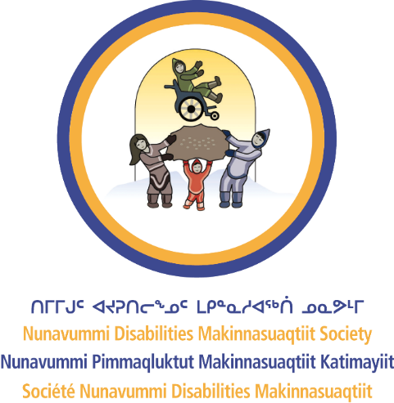
Nunavummi Disabilities Makinnasuaqtiit Society
WHAT WE DO

A Guide to Our Services
One of the best ways to learn about what we do is to review some of the SERVICES we offer. In this resource, you will learn more about the services that we offer in NDMS.

NDMS’s Services
Advocacy – Advocacy is at the heart of what we do. We may advocate for an individual (Nunavummiuq), support individuals to advocate for themselves, or advocate for a legislative change.
Employment Support – We take a holistic approach toward employment support by engaging both the employer and employee. This means we support individuals to gain the skills needed to secure employment (e.g., sector-specific training, job coaching). It also means we may offer wage subsidies and cover tuition and childcare costs.
Accessible Sports – We believe everyone has the right to be part of recreational or competitive sports. We support initiatives where Nunavummiut who have disabilities can be included, such as soccer and swimming.
Social Development – We believe everyone has the right to be part of the community they live in. We support initiatives where Nunavummiut who have disabilities can be included, such as community gatherings and celebrations.
Elder Support – NDMS has an Elders Care Web to support elders in everything from meal prep to drop-off/pick-up for appointments, to snow removal, to home visits and companionship.
Research – We are always exploring ways to further support Nunavummiut living with disabilities. This includes learning more about accessibility standards and Inuit Societal Values, women and gender equality, and the relationship between homelessness and disability.
To learn more about our services, review our website: https://nuability.ca/

