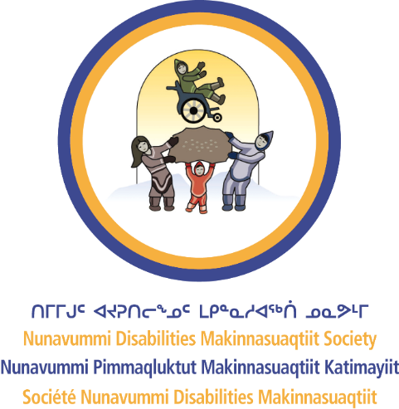
Nunavummi Disabilities Makinnasuaqtiit Society
QUICK TIPS: BUSINESS CASE

The Business Case for Inclusive Hiring
As an employer in Nunavut, you know how challenging it can be to find and hire great employees. What you might not realize is that many talented individuals in your community are ready to work. These skilled and hardworking candidates are already here, looking to contribute, but they often face barriers to employment.
When you remove barriers to diverse hiring, you get great employees…
As an employer, you:
- Gain reliable, productive employees.
- Show that your business welcomes diversity.
- Strengthen Nunavut’s economy by increasing local spending power.
- Help build an inclusive workforce where everyone benefits.

Why is inclusive hiring good for business?
- You amplify your customer base by creating an inclusive and supportive work environment.
- You strengthen your community’s spending power.
- You help build an inclusive society where everyone can contribute.
- Hiring people with disabilities enhances your business performance by bringing diverse perspectives.
- With their strong work ethic and reliability, it leads to better retention and overall productivity.
- Having an inclusive workforce can improve your company's reputation, attract ethical consumers, and create a more innovative and welcoming workplace.
- Building a more inclusive world creates opportunities for everyone to thrive.

Small changes, big impact
You can start today by:
- Using welcoming language in job postings.
- Partnering with a job coach to support employees.
- Providing reasonable accommodations to ensure all employees thrive.
Get in touch with us to get started today!

Remember, when we all see ourselves reflected in the workforce, we all do better—together!

