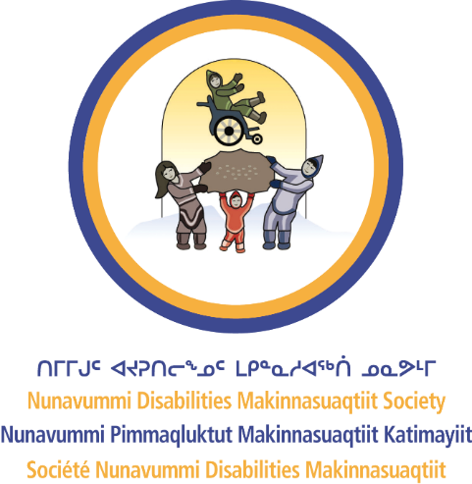
Nunavummi Disabilities Makinnasuaqtiit Society
COMMUNICATING INCLUSIVELY

Understanding communication barriers
Here are common communication barriers in the workplace:
- Misunderstandings occur when people assume they understand each other without checking.
- Gossip can create a negative workplace environment and lead to miscommunication.
- Avoiding communication can cause confusion, especially when employees do not ask questions.
- Oversharing personal information can make others uncomfortable and disrupt professional boundaries.

Strategies for inclusive communication
Here are some strategies to remove communication barriers:
- Practice active listening by focusing on the speaker and responding thoughtfully.
- Seek clarification if something is unclear to avoid misunderstandings.
- Ensure all voices are heard, especially those who may be less outspoken.
- Adjust communication styles to be respectful and inclusive of different perspectives.
- Use simple and clear language to enhance understanding for everyone.

Systemic and organizational barriers
Workplace communication can be challenging. Some barriers come from workplace systems that unintentionally make it harder for certain people to take part. Understanding these barriers is the first step to making communication more inclusive and accessible.
- Some individuals may face language barriers that make workplace communication difficult.
- Workplace culture may favor certain communication styles, creating exclusion for others.
- Systemic barriers, such as unclear policies or inaccessible communication channels, can prevent equal participation.
- Inclusive workplaces provide multiple ways for employees to communicate and express their thoughts.
To create a more inclusive workplace, we must recognize these barriers, understand why they exist, and take steps to address them whenever possible. Small changes can lead to a more accessible and equitable work environment.

Encourage teamwork and collaboration
Encouraging teamwork and collaboration helps build a more inclusive and productive workplace. Here are ways to promote effective teamwork:
- Encourage collaboration by valuing each team member's input.
- Use open dialogue to ensure employees feel comfortable expressing concerns.
- Provide opportunities for team-building activities to strengthen workplace relationships.
- Create an environment where feedback is welcomed and encouraged.
By addressing communication barriers and using inclusive strategies, workplaces can create an environment where everyone feels valued and heard.

