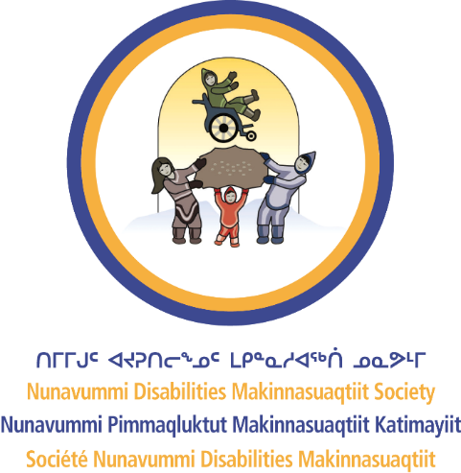
Nunavummi Disabilities Makinnasuaqtiit Society

INCLUSIVE INTERVIEW QUESTIONS

How to use this document: Use this template together with the Inclusive Interview Checklist to design an interview experience that supports candidates to showcase their skills.
Remember to:
- Rewrite your interview questions to be more inclusive.
- Reframe your interview questions to ask “how” instead of “can.”
- Be prepared to ask questions in more than one way.
- Provide clarification if the candidate asks.
- Assess if the candidate has the skills to perform the job.

Common interview questions
QUESTION |  | TRY INSTEAD | RATIONALE FOR THE REWRITE
 | Tell me about yourself. | Thank you for being here today. Are you ready to get started with the interview? | The purpose of this question can be vague. It can also be unclear if you are making conversation or if the interview has started.  Be clear by thanking the candidate and asking them if they are ready to start.  Try starting with a question about a job listed on their resume.
 | Tell me about a time when you acted with integrity. | Tell me about a time when you had to make change for a customer. How did you do it? | The first question is a behavioural question that asks about integrity, but it may be too abstract. The purpose of your question may not be clear.  Try asking about a specific skill instead. Ask the candidate how they performed that specific skill. Be clear about what you are trying to learn.
 | What are your strengths and weaknesses? | Tell me some things you’re really good at.  You could follow up this question by asking for an example from a past job or from their personal life. | Avoid asking two questions in one sentence.  It can be difficult for a candidate to focus on which one to answer.  Try shorter, simplified sentences that ask one thing at a time.  Ask one thing at a time.

