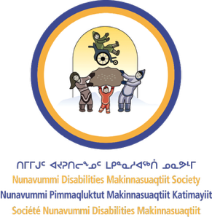

Nunavummi Disabilities
Makinnasuaqtiit Society
BUSINESS CASE

Table of contents
Introduction 3
Understanding disability in Nunavut 4
Benefits for your business 5
Respond to talent skills and shortages 7
Reflect the market you serve 7
Benefit your community 7
How can NDMS help you? 8
Next steps 9

Introduction
Talent and labour shortages are affecting employers across Nunavut and Canada. Due to the remote location and relatively small population of Nunavut, the impacts may be felt more acutely by employers here. The good news is, there are potential employees in your community ready to work today. You can access this untapped pool of talent by committing to creating a barrier-free, welcoming, and inclusive work environment for all people, including those with disabilities.
People with disabilities are underrepresented in the workforce. This presents a unique opportunity for employers like you. There are clear business benefits, both direct and indirect, to adopting barrier-free and inclusive employment practices.
Inclusive workplaces are good for business. Research shows that inclusive practices help to:
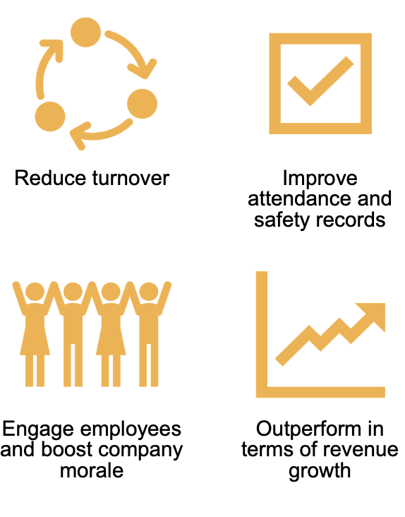

You can thrive by hiring and retaining the talent that you need, including people with disabilities. Using this business case, the accompanying tool kit, and the support of organizations like NDMS, you can transform your hiring and employment practices. Reading this business case is the first step. Begin today and start to access the benefits of an inclusive workplace, including attracting new talent with disabilities and supporting employees with disabilities – or those who may develop disabilities – to remain in the workforce.

Understanding disability in Nunavut
According to the Nunavut Human Rights Act of 2011, the term “disability” now means any previous or existing or perceived mental or physical disability and includes disfigurement and previous or existing dependency on alcohol or a drug.
Given this expanded definition of disability in Nunavut, you could anticipate getting applications from a larger number of people who have a need and desire to work and are capable to do so, with a little extra support from their employer.
Additionally, there is an increasing awareness and diagnostic opportunity for Nunavummiut identifying with Fetal Alcohol Spectrum Disorder (FASD). FASD covers a range of mental and physical disabilities and is the most common cause of developmental disability in Canada.
FASD is a lifelong disability, and the volume of people living with FASD throughout their lives – as children, youth, and adults – is projected to be a substantial number in Nunavut. It is anticipated that the number of people self-identifying as living with disabilities will continue to rise in the years to come.
Currently, there are no statistics available for the number of people living with disabilities in Nunavut. However, with the expanded definition of disability, it may be anecdotally estimated that up to 90% of the population may experience disability. Gathering statistics about the number of people living with a disability is a barrier, as there is no word in Inuk for disability. Thus, Inuk may not self-identify as having a disability. The word to use instead is barriers, so wherever possible, frame the idea of inclusive hiring as removing barriers to employment.
The Federal Government and the Government of Nunavut signed the Labour Market Agreement for Persons with Disabilities (LMAPD) in 2014. The main objectives were:

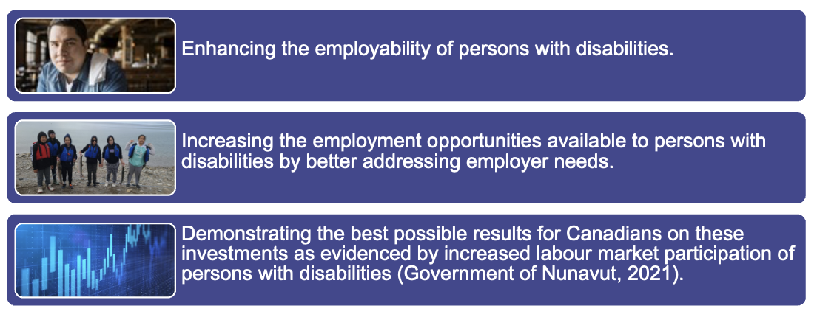
Under this agreement, the Government of Canada and the Government of Nunavut provide funding, while the Government of Nunavut administers and manages the program, to achieve these objectives. The only prominent program offered by the Government of Nunavut to achieve the objectives is the Targeted Labour Market Program that provides funding of up to one year in duration to eligible employers, institutions, and training providers to enable Nunavut-based education and/or training for occupations or skills that either are or will be in demand in the near future (Government of Nunavut, 2021).
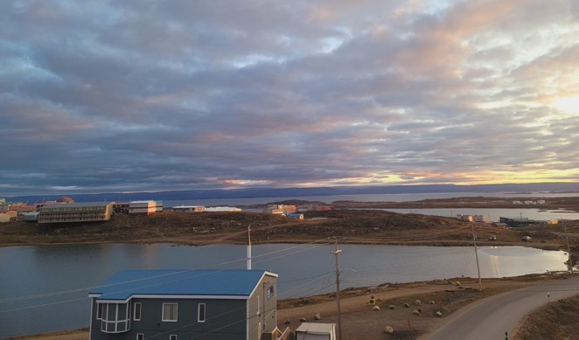

Benefits for your business
How can removing barriers to access for employment for people with disabilities benefit your business?
Across all industries, the average employee turnover rate in Canada is 49% (Ready, Willing & Able). Recruiting new staff, training, and orientation, and covering missed shifts all takes time and resources. The turnover rate for employees with an intellectual disability or autism spectrum disorder is only 7% (Ready, Willing & Able).
This is just one example of the benefits of inclusive hiring. Accessible and inclusive workplace policies reflect your organization’s commitment to a thriving workplace for all. Companies that are committed to creating inclusive workplaces:
- Have stronger brands.
- Enhance their public images by being seen as good corporate citizens.
- Extend their reach by accessing a larger talent pool.
- Become more resilient and adaptive.
- Are better at attracting and retaining talent.
- Foster innovation and build business capacity.
- Expand their customer bases (Hire for Talent, n.d.).
Ensuring accessibility and inclusiveness creates a better workplace for all employees. Employers that apply inclusive design principles and take steps to develop more inclusive workplaces will:
- Make employment more accessible.
- Leverage the benefits of diversity.
- Create healthier workplace cultures for all employees.
- Boost the value of their human capital.
- Provide opportunities for all employees to learn about inclusiveness and accessibility (Hire for Talent, n.d.).
Inclusive hiring adds employees to your team who want to work and take pride in getting the job done.
Many positive outcomes can occur both at your organization and in your community when you commit to removing barriers to employment and hiring diverse people including those with disabilities. In addition to having a positive impact on many aspects of doing business, you can expect to:
- Respond to imminent talent and skills shortages by taking advantage of a relatively untapped pool of talent.
- Reflect the markets you serve.
- Benefit your community.

Respond to talent skills and shortages
By removing barriers to employment, you gain dedicated and effective employees to keep your business running smoothly.

Many employers in Nunavut such as yourself are experiencing staffing shortages. To fill this gap, employers may bring in employees from outside of the territory.
Due to the remote location of Nunavut, operating a business can already be more expensive compared to other Canadian jurisdictions. Adding additional costs to recruit from other areas may not be feasible or desirable to fill staffing shortages.

Reflect the market you serve
By reflecting the market that you serve, you can significantly amplify your customer base.

The Canadian marketplace, including Nunavut, is becoming more diverse. It’s estimated that the income controlled by people with disabilities and those at risk of disability (those aged 55 and above) in Canada will be $536 billion by 2031 (Kemper, Stolarick, & Milway, 2010). Friends and families of these people may be more likely to support businesses that are inclusive of those with disabilities. This represents a large amount of spending power in Canada.
By identifying diversity in the market that you serve, and seeking to reflect that market in your workplace, you can access this growing group of individuals and the portion of the market they represent. The first step is to create a supportive and barrier-free work environment for all people, including those with disabilities.

Benefit your community
By reducing barriers and creating a more diverse workforce, you are supporting societal change that increases spending power.

Inclusive workplaces help build inclusive societies where everyone can participate. When barriers are removed and ready-and-able people can enter the workforce, they can more fully participate, thus:
- Reducing the burden on government welfare programs funding, and
- Boosting both the local and national economy by more spending because they are earning more.
You also benefit your community by setting an example for cultural change. Individual and societal mindsets – people’s opinions – are a barrier to inclusive and diverse employment. Your choice to include diverse individuals in your workforce signals a cultural change. The impact of this change may radiate into your community, challenging any limiting beliefs held in your community about those with disabilities.

How can NDMS help you?
Nunavummi Disabilities Makinnasuaqtiit Society, also known as NDMS, is the only cross-disability organization in Nunavut. We provide support to people across the lifespan from infants to Elders.
Our vision is for all people with disabilities living in Nunavut to achieve independence, self-determination, and full citizenship and participation in their communities (Nuability, 2020). Our main objectives are:
- To improve the quality of life for persons with disabilities in Nunavut.
- To encourage persons with disabilities to become actively involved in their communities.
- To advocate and lobby for the rights and interests of persons with disabilities; and
- To promote employment opportunities for persons with disabilities (Nuability, 2020).
We offer a variety of services and support for job seekers and employers to fully participate in their communities, including supporting employment. Our programs include:
- Advocacy services for people with disabilities, from children and youth to adults and Elders.
- Monthly roundtable discussion and disability committee about disability-related topics.
- Various workshops including resume building, inclusive hiring, accessibility devices, and technology.
- The Nunavut Solutions Grant (a joint venture between the NDMS, the Rick Hanson Foundation, and the Government of Nunavut) that provides funding for those living with a mobility-related disability to access equipment or services that will improve the quality of life for Nunavummiut.
- Job coaches to help employers and employees to effectively deal with disability and inclusion in the workplace. NDMS also offer a comprehensive job coach program to help develop skills and abilities for job coaches across Nunavut (Nunavummi Disabilities Makinnasuaqtiit Society, 2020).

Next steps
- Continue with the employer tool kit and get started with developing your barrier-free and inclusive practices today. Remember, even a small change can make a bit impact.
- Register for one of NDMS’s employer workshops to learn more and practice your inclusive hiring skills with a facilitator and a group of peers.
- Contact NDMS today to find out more, access additional resources, or begin working with a job coach.

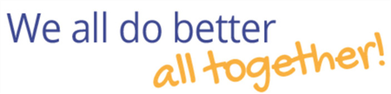


CONTACT US

Nunavummi Disabilities Makinnasuaqtiit Society (NDMS)
 | Visit our website: www.nuability.ca
 | Email: connect@nuability.ca
 | Toll-free: 877.354.0916  Local: 867.979.2228

